COSC 1435 Introduction to Problem Solving with Computers I

Homework Assignment 3

*Name: Kevin White*

* Algorithms

1. The following pseudocode was designed to compute the largest integer whose square is not greater than N. (If N is 5, then the procedure should print the value 2.) Find and correct the logic error. [10 points]

procedure squareRoot (N)

X ← 0

while (X2 ≤ N)

X ← X + 1

end while

X🡨X – 1;

Print X

1. Write an algorithm in pseudocode that can be used by the TA of this course to calculate the total score of assignments based on the late policy described in this course syllabus. [15 points]
   1. Print “Enter Grade before modified and hours late”
   2. Get grade & hours
      1. If(hours <24)
         1. grade 🡨 grade -25
      2. else if( hours <= 48)
         1. grade🡨grade-50
      3. else
         1. grade 🡨 0
      4. end Else
   3. Print “Students final grade is: “grade
2. Write an algorithm in pseudocode that performs the XOR operation on two inputs (entered by the user) and displays the output. Assume the inputs can take only the values 0 or 1. Example: if the user enters 0 and 1 the output should be 1. [15 points]
   1. Print “enter 2 binary values”
   2. Get X,Y
      1. If(X AND !Y)
         1. Xny 🡨1
      2. Else
         1. Xny🡨0
      3. End if
      4. If(Y AND !X)
         1. Ynx🡨1
      5. Else
         1. Ynx🡨0
      6. End if
      7. If(Xny or Ynx)
         1. Xor🡨1
      8. Else
         1. Xor🡨0
      9. Endif
   3. Print ”the output is: ”Xor
3. Write the pseudocode and create the flowchart for an algorithm that accepts two integers from the user and displays the integers between them, inclusive, in ascending order. The program is also required to calculate and display the average of these integers. *The algorithm should work with any inputs*. [30 points]

Print “enter two numbers”

Get x,y

Count 🡨1

Sum🡨x

Print x

While(x<y)

X 🡨 x+1

Print x

Count 🡨 count+1

Sum🡨sum+x

End while

Average🡨sum/count

Print “the average of all these numbers is: ”average

1. **Lab Activity 4:** 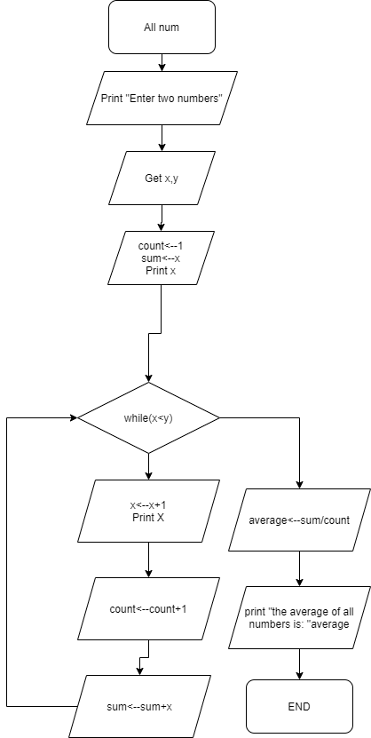

Write the pseudocode and create the flowchart for an algorithm that performs multiplication of two numbers entered by the user using addition (For example: 2*3 = 2+2+2, 4*2 = 4 + 4). [30 points].

***The algorithm should work correctly with negative values***

Answer = 0

Print “Enter two numbers to multiply”

Get x,y

If(x>=0 AND y >=0)

While(y>0)

answer = answer + X

y = y-1

end while

Else If(x < 0 AND y < 0)

X = x – x – x

Y = y – y – y

While(y>0)

answer = answer + X

y = y-1

end while

else

if( x < 0)

X = x – x – x

Else

Y = y – y – y

End if

While(y>0)

answer = answer + X

y = y-1

end while

answer = answer – answer – answer

end if

Print answer

END

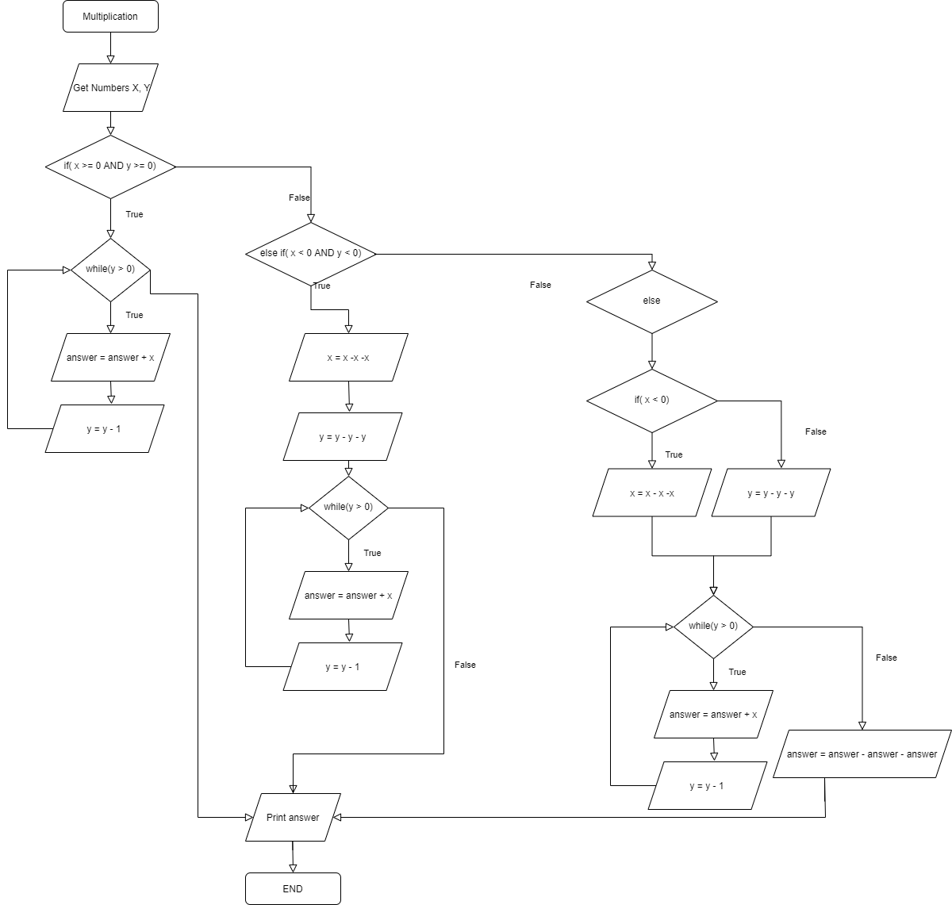

**What to submit?**

* Please use this document to submit your answers (Save As). Write your answers under the respective questions. Make sure you write your name in the designated space.
* The name of the file must be **firstInitialLastNameAssign3.docx.** Example, for the name Joe Smith, the file name should be **jSmithAssign3.docx** *
* Submit the file to Blackboard by the due date

*\* -2 points for not following file naming convention*